Praktikum 4
Routing Extended Interior Gateway Protocol

No | Keterangan
1 | Buatlah Topologi dengan Packet Tracer sebagai berikut
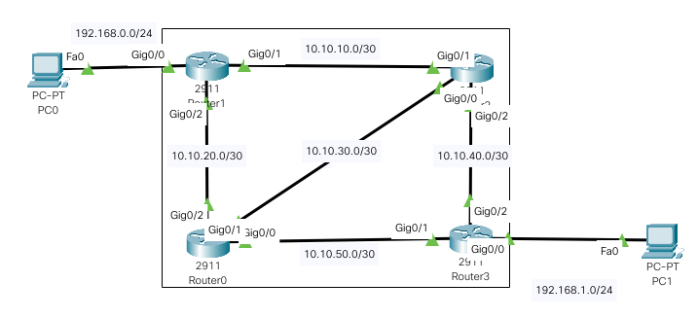
2 | Berikan IP kepada Router 2911 dan PC sebagai berikut
Router0:
GigabitEthernet0/0 - 10.10.30.2 255.255.255.252
GigabitEthernet0/1 - 10.10.50.1 255.255.255.252
GigabitEthernet0/2 - 10.10.20.2 255.255.255.252

Router1:
GigabitEthernet0/0 - 192.168.0.1 255.255.255.0
GigabitEthernet0/1 - 10.10.10.1 255.255.255.252
GigabitEthernet0/2 - 10.10.20.1 255.255.255.252

Router2:
GigabitEthernet0/0 - 10.10.30.1 255.255.255.252
GigabitEthernet0/1 - 10.10.10.2 255.255.255.252
GigabitEthernet0/2 - 10.10.40.1 255.255.255.252

Router3:
GigabitEthernet0/0 - 192.168.1.1 255.255.255.0
GigabitEthernet0/1 - 10.10.50.2 255.255.255.252
GigabitEthernet0/2 - 10.10.40.2 255.255.255.252

PC0 : 192.168.0.2 255.255.255.0, GW: 192.168.0.1
PC1 : 192.168.1.2 255.255.255.0, GW: 192.168.1.1
3 | Konfigurasikan EIGRP Routing
Router0:
Router>ena
Router#config t
Enter configuration commands, one per line. End with CNTL/Z.
Router(config)#router eigrp 1
Router(config-router)#net 10.10.20.0
Router(config-router)#net 10.10.30.0
Router(config-router)#net 10.10.50.0

Router1:
Router>ena
Router#config t
Enter configuration commands, one per line. End with CNTL/Z.
Router(config)#router eigrp 1
Router(config-router)#net 10.10.10.0
Router(config-router)#net 10.10.20.0
Router(config-router)#net 192.168.0.0

Router2:
Router>ena
Router#config t
Enter configuration commands, one per line. End with CNTL/Z.
Router(config)#router eigrp 1
Router(config-router)#net 10.10.10.0
Router(config-router)#net 10.10.30.0
Router(config-router)#net 10.10.40.0

Router3:
Router>ena
Router#config t
Enter configuration commands, one per line. End with CNTL/Z.
Router(config)#router eigrp 1
Router(config-router)#net 10.10.40.0
Router(config-router)#net 10.10.50.0
Router(config-router)#net 192.168.1.0

4 | Cek Router Untuk Keberhasilan Routing, show ip route. Contoh: Router0
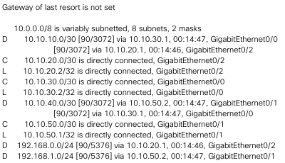
5 | Tes PING dari Ujung ke Ujung, dan Pastikan Sukses
6 | Selesai

